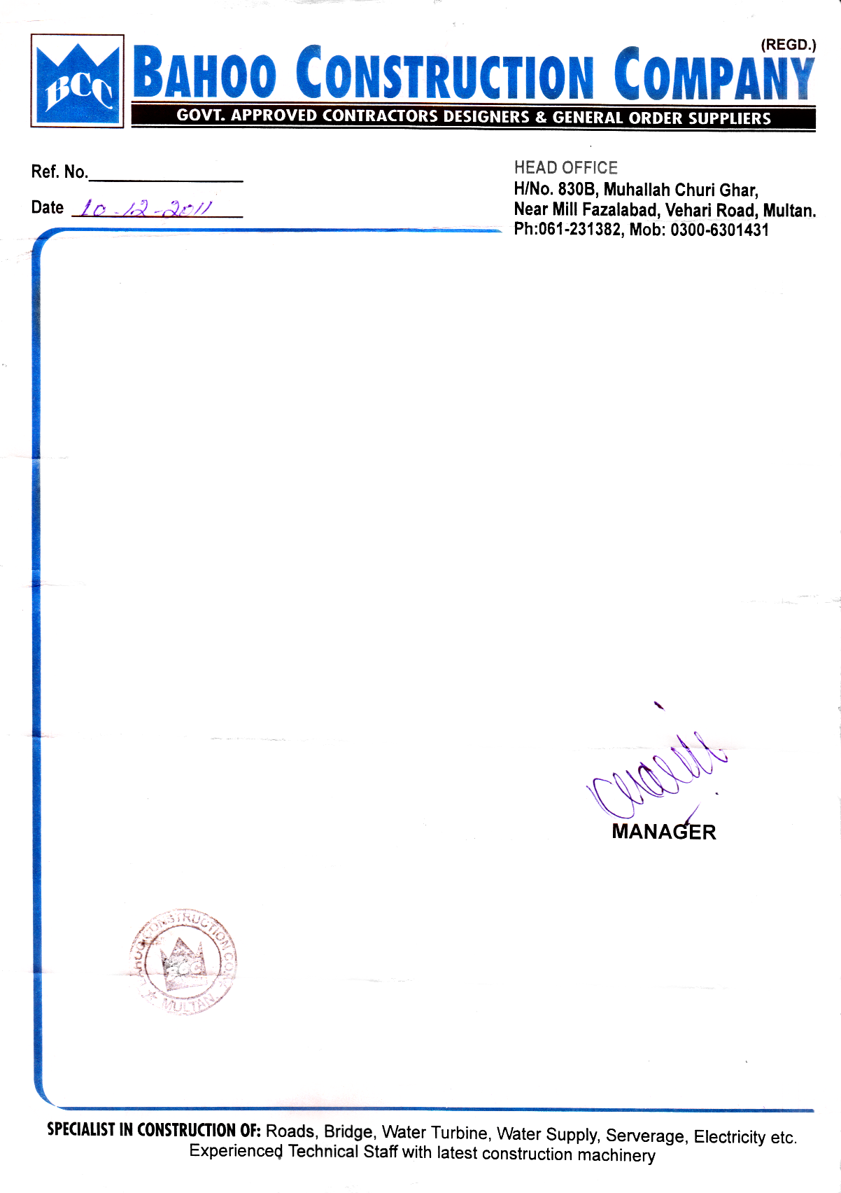

**EXPERIENCE CERTIFICATE**

It is certified that MR. <Name> S/O <fname> bearing N.I.C. # <CNIC> working as a <Designation> and know PTO System very well in our organization from <From> to <To>.

During his stay in the organization his work & conduct was very good. He is very honest & hard worker & duty full.

We wish him success in every phase of life.